Lab - Guideline
Topics
- Switches and bridges
- Spanning-Tree Protocol
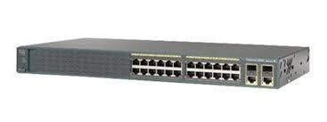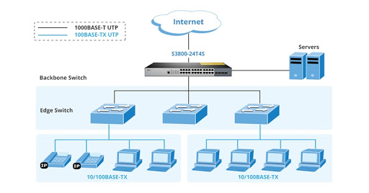
- Switches and bridges
- layer 2 devices
- switching data frames and maintaining switching operations
Switching is classified as
- symmetric
- asymmetric
Switching modes are classified as:
- store-and-forward: buffer entire frame
- cut-through: read at least destination address (MAC)
  - fast-forward: read destination address (MAC)
  - fragment-free: read the first 64 bytes (512 bits) of the frame
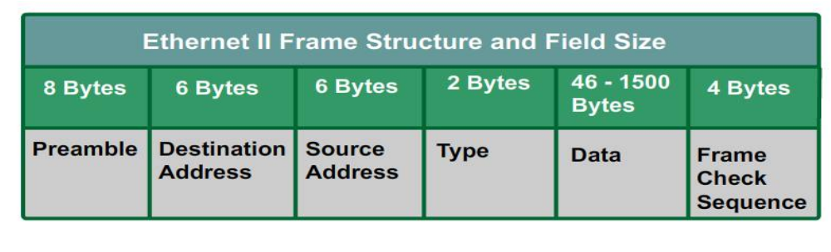
- Spanning-Tree Protocol
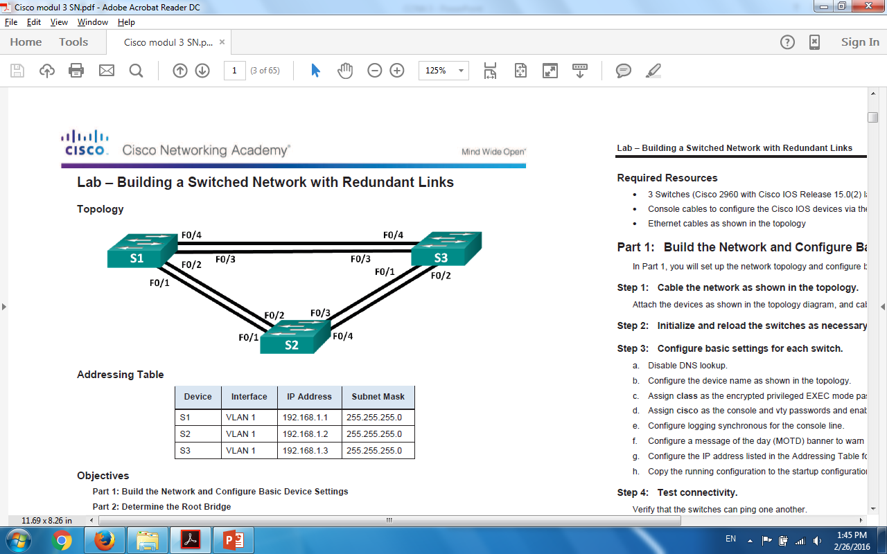 | 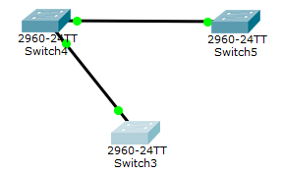
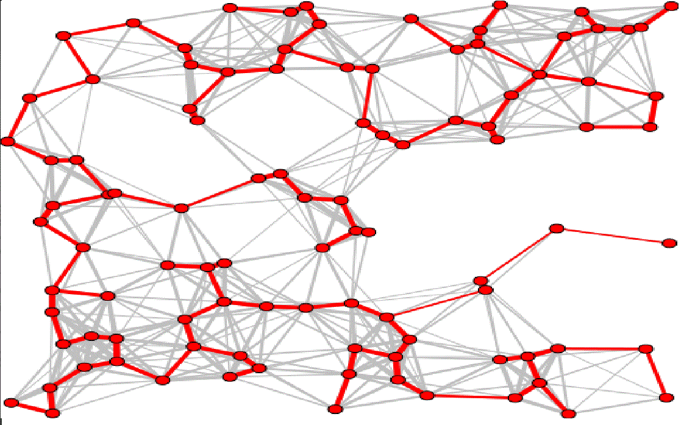

BPDU – every 2 secs: | Root BID | Root Path Cost | Sender BID | Port ID
BPDU structure
Bridge Priority | MAC address
BID structure
Port Priority | Port Number
Port ID structure
Link Speed | Cost
10Mbps | 2000000
100Mbps | 200000
1Gbps | 20000
10Gbps | 2000
1Tbps | 20
10Tbps | 2
Link Cost/Speed
Elect root bridge -> calculate the shortest path from itself to the root bridge --> Spanning-Tree
Port states: blocking, listening, learning, forwarding and disabled
Lab configuration
 |  | FA0/4 |  | FA0/3
 |  | FA0/2 |  | FA0/2
Host1 |  | FA0/3 |  | FA0/4 |  | Host2
 |  | Switch1 |  | Switch2

Choose IP addresses for the hosts and the switches (from the same network – example 192.168.1.0/24)
Switch(config)# hostname host_name
- Replace host_name with your name

Configure the primary terminal line with the following commands:
- line console 0
- password password
- login
- exit
- Replace password with your name

Configure virtual terminal with the following commands:
- line vty 0 4
- password password
- login
- exit
- Replace password with your name

Configure IP address and default gateway with the following commands:
- interface VLAN1
- ip address ip_address netmask
- no shutdown
- exit
- ip default-gateway default_gateway_address

Visualize spanning-tree configuration
Switch# show spanning-tree
Change switch priority
Switch(config)# spanning-tree vlan 1 priority 0
Change switch port priority
Switch(config)# interface fastethernet 0/4
Switch(config-if)# spanning-tree vlan 1 port-priority 0
Visualize spanning-tree configuration
Switch# show spanning-tree

